Functional specification

One Credit Engine

Revaluation

Version: 1.2

Change History

Date | Version | Revised chapters | Description | Changed by
2016-07-11 | 0.1 |  | Initial version | Fredrik Johannesson
2016-07-15 | 1.0 |  | Final version 1 | Fredrik Johannesson
2016-10-05 | 1.1 |  | Update of sections PseudoAccount and CurrencyCode. If add/delete actions done then initial record in RevalueAccounts will be created / deleted | Fredrik Johannesson
2016-10-05 | 1.1 |  | Section 4.1 – step 1/d/ii  If no change found OR PA_Revaluation = 1:  The OR clause and following condition deleted | Fredrik Johannesson
2016-10-06 | 1.2 |  | Major changes in revaluation batch workflow | Fredrik Johannesson

Table of Contents
1 Introduction 4
1.1 Modification Overview 4
2 Current functionality 5
3 New functionality 6
3.1 General process flow 7
3.2 Activation of Revaluation concept 8
3.3 Pseudo Account 8
3.4 Currency Code 9
3.5 Formula 9
3.5.1 Booking Rules form 10
3.5.2 New Formulas 10
3.6 Update of new table RevalueTransactions 10
3.7 Tables 11
3.7.1 Table RevalueAccounts 11
3.7.2 Table RevalueTransaction 11
3.7.3 Table RevalueTransactionsHistory 11
3.7.4 Table CurrencyCode 12
3.7.5 Table BookingType 12
3.7.6 Table Transaction Type 12
3.7.7 Table RevalueSchedule 12
4 Detailed description 14
4.1 Revaluation batch 14
5 Translation of forms and error messages 17
5.1 Form 1 17
5.1.1 Translations 17
6 Other areas affected 17
6.1 Pseudo Account 17
6.2 Formulas 17
6.3 Update of System Documentation 17
6.4 Migration 17
7 Open issues 18

Introduction
As a part of migration of Atlas Copco Finance (ACF) to from version 2.5 to 4.5 (DotNet), functionality for revaluation must be available since ACF uses this concept in their current 2.5 version.
However, a decision has been taken to abandon current method that deals with currency rates at detail levels (contract, customer invoice, supplier invoice etc.) and instead implement a new solution that is based on revaluation of specific accounts and their related bookings.

Modification Overview
Entity AccountingModules
Formula
ContractBooking
Monthly Update
Currency Code
Contract Start
New Entity RevalueAccounts
New Entity RevalueTransactions
New Entity RevalueTransactionsHistory
New Entity RevalueSchedule
New routine Monthly Revaluation

New functionality
The implementation of revaluation will be strictly based on pseudo account opening balances and pseudo account transactions during a specific month, for pseudo accounts defined as “Revaluation”. It should be possible to exclude formulas from revaluation when used on pseudo account set for revaluation – this to make it possible to create formulas that use historical currency rates defined at contract registration.
The methodology is to:
- Revaluate the total opening balances per currency to current rates
Revaluate all transactions created in current month to current rates
- Summarize 1 + 2 creating revaluated closing balances
- Establishing new opening balances for next month by using result from step 2.
Two new entities will be implemented to support the methodology above.
- RevalueAccounts
Balance records for pseudo accounts defined for Revaluation.
Two sets of columns will always exist per account and currency.
  - Balance parts that will be revaluated
  - Balance parts that will not be revaluated
Refers to transactions on pseudo accounts that are set for revaluation but
where a specific formula has been set to no revaluation.
The use of sets of columns is done in order to keep a correct balance including all transactions on a specific pseudo account.
Each month will hold information for accounts and currencies and the balance in both transaction currency and base currency along with the currency rates used at creation of the revaluation bookings for a specific month.
I.e. the actual booked value will be the difference between previous month’s values and the new values calculated for the current month, using current currency rates.
For balance parts not to be revaluated no difference calculation will be made.
Thus it will be possible to track previous revaluations at balance level.
- RevalueTransactions
During the current month all bookings created on pseudo accounts, defined with Revaluation, will also update entity RevalueTransactions.
Each transaction line will have an attribute called Revalue that can be true or false. It will be false if the transaction line use a formula that has been set as no revaluation.
Items with transaction line Revalue setting = true:
The currency rate stored will be the current currency rate at the time of the transaction. Amounts will be stored in both base currency and transaction currency along with the used currency rate.
Items with transaction line Revalue setting = false:
The currency rate stored will be the currency rate that the specific formula is designed to retrieve (e.g. original contract line currency rate). Amounts will be stored in both base currency and transaction currency along with the used currency rate.

General process flow
The revaluation process will be included as a part of the Monthly Update and will be triggered directly when the Monthly Update is completed.
The process has the following steps:
- Monthly Update
Will update entity RevalueTransactions with all transaction lines that are created for pseudo accounts defined for Revaluation (implicit update via trigger on ContractBooking).
- Entity RevalueAccounts
The balances for previous month (for balance items in column-set Revalue) will be revaluated to current currency rate and new records will be created for the current month. The difference between previous and current month will be booked as currency change.
- Entity RevalueTransactions
Each item with booking date <= current month (marked as Revalue=true) will be revaluated to current currency rate, bookings created and the values in the table updated.
Items marked as Revalue will thus not be revaluated.
- Entity RevalueAccounts
Pseudo account balance records for current month, will be updated with the data in table RevalueTransactions. Items with revalue=true will update columnns defined for revaluation and items with revalue=false will update columns defined for no revaluation.
- New closing balance created
Entity RevalueAccounts now holds the new closing value after revaluation.
- Entity RevalueTransactions
All data will be copied to a history table called RevalueTransactionHistory.
Entity RevalueTransactions will then be cleared.
The process is illustrated with a graphic example below:
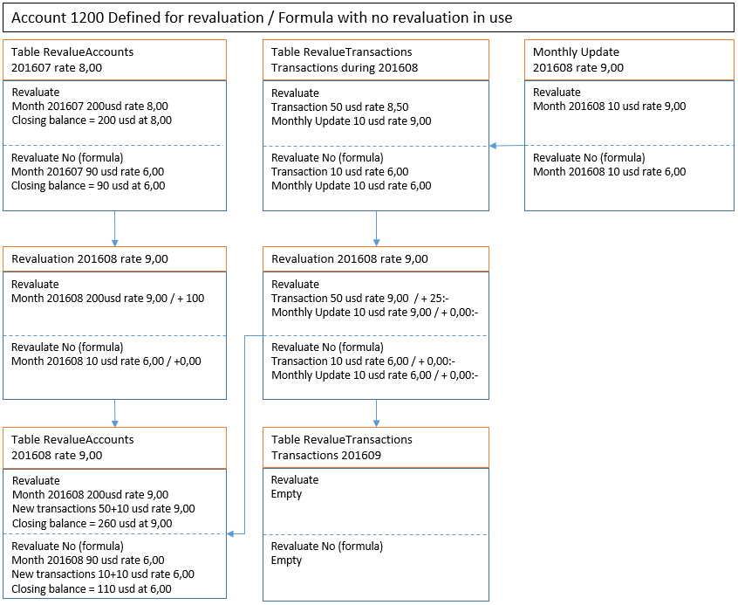

Activation of Revaluation concept
If revaluation as a concept shall be in effect or not will be controlled by a new item in the table CustomerModification named Revaluation. It will have ChangeAllowed=0 (No).

Pseudo Account
A new checkbox will be added to define if an account should be included in revaluation or not.
If revaluation is not in use then the checkbox will hidden and other controls move upwards accordingly, frame height increase and frame bottom aligned with listbox bottom.
Validation at Update if Revaluation checkbox has been changed.
Check if pseudo account has been used in table ContractBooking. If true, update is not allowed and message will be displayed.
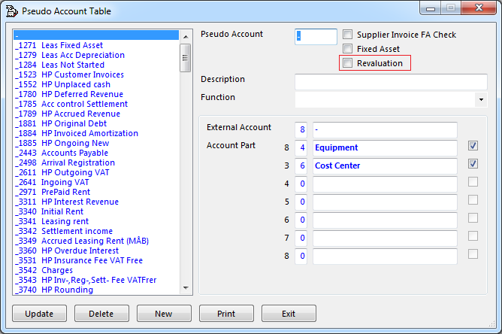
Translations label:
English - Revaluation
French - Réévaluation
Message:
English - Revaluation setting cannot be changed – bookings exists
French - Réévaluation ne peut pas être modifié – transaction de comptabilasition existe

If new PseudoAccount is added with Revaluation set to 1, table RevalueAccounts need to be populated for new PseudoAccount and all currency codes.
Currency rate will be copied from CurrencyCode table and all other amounts will be 0.
If PseudoAccount is deleted and table RevalueAccounts only have rows with amount = 0, table RevalueAccounts will also be cleaned for that PseudoAccount.

Currency Code

If new currency code is added , table RevalueAccounts should also be populated with new currency code and all PseudoAccounts with Revaluation set to 1.
If currency code is delted and table RevalueAccounts only have rows with amount = 0, table RevalueAccounts will also be cleaned for that currency code.

Formula
A new checkbox will be added to define if a formula should be excluded from revaluation.
If revaluation is not in use then the checkbox will be hidden.
By excluding a formula from revaluation it is possible to create a formula that will use for example the currency rate defined at contract registration and then set this formula to no revaluation.
Validation at Update if Revaluation checkbox has been changed.
Check if formula has been used in table ContractBooking. If true, update is not allowed and message will be displayed.
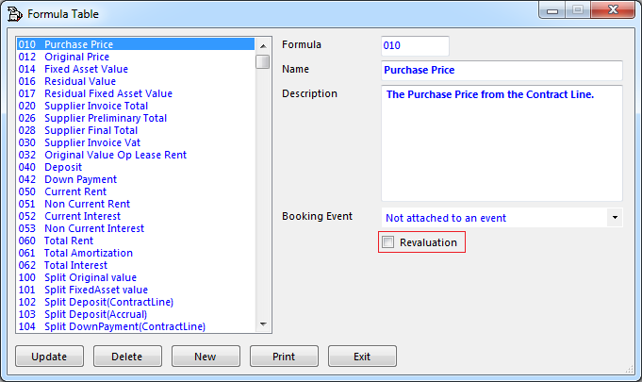
Translations label:
English - Revaluation
French - Réévaluation
Message:
English - Revaluation setting cannot be changed – bookings exists
French - Réévaluation ne peut pas être modifié – transaction de comptabilasition existe

Booking Rules form
The “rev” transaction type shall only be included in the transaction type listbox if CustomerModification revaluation = 1. Otherwise it shall be excluded from transaction type listbox.
The mrt and mrb booking types shall only be included in the booking type listbox if CustomerModification revaluation = 1. Otherwise it shall be excluded from booking type listbox.

New Formulas
- 015 – Fixed Asset Value (Historical Rate)
Copy ACF014 from Atlas Env.
- 311 – Monthly Depreciation (Historical Rate)
Copy ACF310 from Atlas Env.
- 421 – Accumulated Depreciation (Historical Rate)
Copy ACF420 from Atlas Env.
- 998 – Revaluation Transactions
New formula for booking changed amounts in tables RevalueTransactions.
- 999 – Revaluation Accounts
New formula for booking changed amounts in tables.

Update of new table RevalueTransactions
Each time an item is entered in table ContractBooking a validation must be done if any of the pseudo accounts are defined for revaluation. If this is true a record must be created in table RevalueTransaction.
The suggested way of solving this is to create an insert trigger on ContractBooking that will create the record in RevalueTransactions if the trigger condition is met (i.e. pseudo account set for revaluation and revaluation modification is on).

Tables

Table RevalueAccounts
The table will store the pseudo accounts balances on accounts defined as Revaluation for each month.
Columns:
- RA_Account
- RA_YearMonth
- RA_CurrencyCode
- RA_CurrencyRatePrev
- RA_CurrencyRate
- RA_BalanceTransCurrencyRev
- RA_BalanceTransCurrencyPrevRev
- RA_BalanceTransCurrencyNoRev
- RA_BalanceTransCurrencyPrevNoRev
- RA_BalanceBaseCurrencyRev
- RA_BalanceBaseCurrencyPrevRev
- RA_BalanceBaseCurrencyNoRev
- RA_BalanceBaseCurrencyPrevNoRev
- RA_TransactionRevalue
- RA_TransactionNoRevalue
- RA_ClosingBalance
Composite key will be RA_Account+RA_YearMonth+RA_CurrencyCode.

Table RevalueTransaction
The table will store all booking transactions created during a specific month for pseudo accounts defined as Revaluation.
Columns:
- RT_AUID - key
- RT_Account
- RT_Revaluate
- RT_CurrencyCode
- RT_CurrencyRate
- RT_GLINumber
- RT_BookingDate
- RT_TransactionAmount
- RT_BaseCurrencyAmount
- RT_RevaluateAmount
- RT_Status
The status column will be used during processing to keep track what process steps has been made for a specific transaction.
- 0 - Not processed
- 1 - Selected for processing
- 2 - Revaluated
- 3 - Bookings created
- 4 - Table RevalueAccounts updated

Table RevalueTransactionsHistory
The table will store all booking transactions during previous months for pseudo accounts defined as Revaluation.
Columns:
- RH_AUID - key
- RH _Account
- RH _Revaluate
- RH _CurrencyCode
- RH _CurrencyRate
- RH _GLINumber
- RH _BookingDate
- RH _TransactionAmount
- RH _BaseCurrencyAmount
- RH _Status
- RH _RevaluateAmount

Table CurrencyCode
A new column will be added to the table – CT_Locked. The revaluation process will start by setting this new attribute to 1 for all currency tables. A validation will be implemented at form load to check the status of CT_Locked. If 1 a message will be prompted to the user stating “Revaluation in process, Currency cannot be updated” and then a closure of the form will be executed.
When revaluation is completed it will change CT_Locked back to 0 on all currency tables.

Table BookingType
Implement two new booking types for revaluation:
- mrb – Monthly revaluation of BalanceAccounts
- mrt – Monthly revaluation of BalanceTransaction
The new booking types shall only be included in the listbox if CustomerModification revaluation = 1.

Table Transaction Type
Implement new Transaction Type named rev (Revaluation).
TT_Portfolio = 10
TT_TransactionType = rev
TT_Description = Revaluation
TT_Required = 1
TT_ProLedger = 0
TT_Classification = 99
The “rev” transaction type shall only be included in the listbox if CustomerModification revaluation = 1. Otherwise it shall be excluded from listbox.
Implement validation – if TT_Classification = 99 then disable Classification frame in GUI.

Table RevalueSchedule
New table needed in order to keep track on completion level for the two steps in the revaluation.
I.e. revaluation of table RevalueAccounts and table RevalueTransactions.
Columns:
- RS_ScheduleDate
- RS_ScheduleTime
- RS _SchedulePortfolio
- RS_YearMonth
- RS _CompletionLevel
- RS_Information
The first step will always be revaluation of RevalueAccounts. Once that step completes completion level will be set to 10. Then the next step will start for revaluation of table RevalueTransactions.
The steps will set the following completion levels:
- 10 - Revaluation of table RevalueAccounts completed, table CurrencyCode locked
- 21 - Items in table selected for revaluation
- 22 - Revaluation of selected items completed
- 23 - Bookings created
- 24 - Table RevalueAccounts updated
- 30 - Table RevalueTransaction cleared of processed.
- 40 - CurrencyTable unlocked - revaluation completed
The field RS_Information can have one of the following values:
- No currency rate change and no new transactions
- Currency rate change but no new transactions
- No currency rate change but new transactions
- Full revaluation completed

Detailed description

Revaluation batch
The revaluation process will be started directly as part of the Monthly Update when the current monthly update batch/process has completed. A batch revaluation job will be created in table ActivityScheduleControl and RevalueSchedule.
The logical processing will be:
- Revaluation of table RevalueAccounts
  - Begin Transaction
  - Update table CurrencyCode - set CT_Locked = 1 for all records.
  - Create records for new months if not already existing
AND PA_Revaluation is still 1:
    - Copy all records from previous month and change YearMonth to current
    - Copy RA_CurrencyRate to RA_CurrencyRatePrev
    - Set RA_CurrencyRate = 0,00
    - Copy RA_BalanceTransCurrencyRev to RA_BalanceTransCurrencyPrevRev
    - Copy RA_BalanceBaseCurrencyRev to RA_BalanceBaseCurrencyPrevRev
    - Set RA_BalanceBaseCurrencyRev = 0,00
    - Copy RA_BalanceTransCurrencyNoRev to RA_BalanceTransCurrencyPrevNoRev
    - Copy RA_BalanceBaseCurrencyNoRev to RA_BalanceBaseCurrencyPrevNoRev
    - Set RA_BalanceBaseCurrencyNoRev = 0,00
    - Set RA_TransactionRevalue = 0,00
    - Set RA_TransactionNoRevalue = 0,00
    - Set RA_ClosingBalance = 0,00
  - If records for new month exists:
    - Skip step c
    - Check if PA_Revaluation is still = 1
Check if any of the currency rates for current month in table CurrencyCode has been changed compared to table RevalueAccounts.
If no change found:
- Set parameter@BalanceRevalue = 0
- go to step 1.f (skip step 1.e)
  - Revaluate items for current YearMonth
    - Update RA_CurrencyRate for each currency by getting latest value in table CurrencyCode.
    - Calculate new value for RA_BalanceBaseCurrencyRev for each balance record
      - RA_BalanceTransCurrencyPrevRev * RA_CurrencyRate = New value
      - Set RA_BalanceBaseCurrencyRev = New value
      - Set RA_ClosingBalance = RA_BalanceBaseCurrencyRev + RA_BalanceBaseCurrencyNoRev
    - Create booking per balance record
      - Check if active GLI-Number with BookingType mrb exists for current Month (CB_Balanced=0).
If exists then reverse GLI-booking.
      - RA_BalanceBaseCurrencyRev – RA_BalanceBaseCurrencyPrevRev = BookAmount
      - Create line in GLI-Number according to booking rule with amount = BookAmount
      - When all records are processed – update ContractBooking
      - Set parameter@BalanceRevaluate = 1
  - Commit Transaction
  - Update RevalueSchedule – set RS_CompletionLevel = 10
- Revaluation of table RevalueTransactions
  - Begin Transaction
    - Selection
Select all items with RT_BookingDate <= current month
      - If count > 0 Set RT_Status = 1 for each record
      - If count = 0 commit transaction:
- Set parameter@TransactionRevalue = 0
- Go to step 2.p
  - Commit Transaction
  - Update RevalueSchedule – set RS_CompletionLevel = 21
  - Begin Transaction
    - Revaluation
      - Get current currency rate from table CurrencyCode
      - Calculate and update value for RT_RevaluateAmount for items with RT_Revaluate = 1 as:
Current rate * RT_TransactionAmount – RT_BaseCurrencyAmount
      - Set RT_Status = 2 for each record
  - Commit Transaction
  - Update RevalueSchedule – set RS_CompletionLevel = 22
  - Begin Transaction
    - Create bookings
Get RT_RevalueAmount for all records and call GiBooking using BookingType mrt
    - Set RT_Status = 3 for each record
  - Commit Transaction
  - Update RevalueSchedule – set RS_CompletionLevel = 23
  - Begin Transaction
    - Update table RevalueAccounts
      - Check if currency record in RevalueAccounts exists
If not, create new initial record in RevalueAccounts.
      - Update RA_TransactionRevalue for group record (account, currency, revalue = 1):
add sum of RT_BaseCurrencyAmount + sum of RT_RevalueAmount
      - Update RA_TransactionNoRevalue for group record (account, currency, revalue = 0):
add sum of RT_BaseCurrencyAmount
      - Update RA_BalanceTransCurrencyRev for group record (account, currency, revalue = 1):
add sum of RT_TransactionAmount
      - Update RA_BalanceBaseCurrencyRev for group record (account, currency, revalue = 1):
add sum of RT_BaseCurrencyAmount + sum of RT_RevalueAmount
      - Update RA_TransactionNoRevalue for group record (account, currency, revalue = 0) – add sum of RT_TransactionAmount
      - Update RA_BalanceTransCurrencyNoRev for group record (account, currency, revalue = 0):
add sum of RT_TransactionAmount
      - Update RA_BalanceBaseCurrencyNoRev for group record (account, currency, revalue = 0):
add sum of RT_BaseCurrencyAmount
      - Update RA_ClosingBalance
Set to RA_BalanceBaseCurrencyRev + RA_BalanceBaseCurrencyNoRev + TransactionRevalue + TransactionNoRevalue.
    - Set RT_Status = 4 for each record
  - Commit Transaction
  - Update RevalueSchedule – set RS_CompletionLevel = 24
  - Begin Transaction
    - Copy all items with RT_Status = 4 to RevalueTransactionHistory
    - Delete all items in RevalueTransactions where RT_Status = 4
  - Commit Transaction
  - Update RevalueSchedule – set RS_CompletionLevel = 30
Set parameter@TransactionRevalue = 1
  - Begin Tran
    - Update table CurrencyCode Set CT_Locked = 0
  - Commit Transaction
  - Update RevalueSchedule
    - Set RS_CompletionLevel = 40
    - If @BalanceRevalue = 0 AND @TransactionRevalue = 0
update RC_Information to “No currency rate change and no new transactions”
    - If @BalanceRevalue = 1 AND @TransactionRevalue = 0
update RC_Information to “Currency rate change but no new transactions”
    - If @BalanceRevalue = 0 AND @TransactionRevalue = 1
update RC_Information to “No currency rate change but new transactions”
    - If @BalanceRevalue = 1 AND @TransactionRevalue = 1
update RC_Information to “Full revaluation completed”

Translation of forms and error messages

Form 1

Translations
Translations are set in the respective chapter they belong to.

Other areas affected

Pseudo Account
All accounts will initially be set with PA_Revaluation = 0.

Formulas
All formulas will be set as revaluation = 1 (on) which means they can be used in booking rules.
Revaluation will only be in effect if the linked pseudo account is set for revaluation.
Exception are the following formulas which shall be set as revaluation off (0)
- 015 – Fixed Asset Value (Historical Rate)
- 311 – Monthly Depreciation (Historical Rate)
- 421 – Accumulated Depreciation (Historical Rate)

Update of System Documentation
All affected forms as described in this specification.
The monthly update main topic.
Link to Zdoc with in depth description (i.e. this specification) in help.

Migration
Initialization of table PseudoAccounts must be made when ACF is migrated from VB6.
For accounts defined as revaluation in VB6, create query that gets current balance in both transaction currency and base currency. This data will be used as initial data in PseudoAccounts table.
Stopped contracts (with stop bookings set) must be manually booked to current rate.
This booking must be addded to the specific pseudo account records in table PseudoAccounts
(is applicable).
Change specific formulas that shall be set as no revaluation.

Open issues
Area | Description | Initiated (date) | Completed (date)
Obsolete columns | ContractInvoicePerCustomer.  IL_BookCurrRate, IL_BookCurrDate.  Shall the columns be removed?
Obsolete columns | ContractInvoicePerCustomer.  IL_BookCurrRate, IL_BookCurrDate  Shall the columns be removed?
Obsolete columns | Other tables  Shall the columns be removed?
Obsolete formular | 900,980,982,986,990,992,996  Refer to “old” revaluation methods.  Should be removed

